**WESTON NEWS**

2024-25 ISSUE 4: 18 OCTOBER 2024

Website: weston.cheshire.sch.uk

Facebook: westonvillageprimary

X: @WestonVillagePS

Dates for your diary (new dates in red):

Tuesday 22 October – Robins stay and learn (8.45-9.30am)

Thursday 24 October - Eagles class assembly (arrive 9.50am for a 10am start); Puffins stay and learn (8.45-9.30am); FOWs Krispy Kreme doughnuts day

Friday 25 October - INSET Day (school closed for all children)

Monday 4 November - School reopens

Thursday 7 November – Safeguarding ambassadors to a safeguarding conference

Friday 15 November - Children In Need

Tuesday 19 November - Year 4 Bikeability

Thursday 21 November - Owls class assembly (arrive 9.50am for a 10am start)

Monday 2 December - Eagles class to Crucial Crewe (am); KS2 to New Vic Theatre (pm)

Wednesday 4 December – KS2 Sports Hall Athletics competition

Friday 6 December – FOWs Christmas event tbc

Monday 9 December - Sparrows class nativity (pm and evening)

Tuesday 10 and Wednesday 11 December - Year 5 Bikeability

Wednesday 11 December - EY and KS1 theatre trip (pm)

Thursday 12 December - Magpies class assembly (arrive 9.50am for a 10am start); Robins and Puffins performance (pm and evening)

Tuesday 17 December - Christmas crafts (EY and KS1)

Wednesday 18 December - Choir to perform at Shavington Christmas concert (evening)

Friday 20 December - Weston's Got Talent; Break up for Christmas

A message from Mr Cutts

As we approach the end of this long half term, I’d like to take a moment to reflect on what a successful few weeks it has been. The children have settled in well, embraced their learning and we've enjoyed seeing their enthusiasm for the many events and activities we've hosted so far this term. With the autumn leaves beginning to fall, there’s a real sense of change and progress in the air and it’s wonderful to see how our school community is growing stronger each day.

I’d also like to extend a big thank you to all the parents and carers who attended our recent Parents’ Evenings. Your support and engagement are invaluable and it was a pleasure to have the opportunity to discuss your children's progress. For those who were unable to attend, please don't worry—your child's teacher will be in touch to arrange a more convenient time for a discussion.

As always, please remember that you are welcome to contact your child’s teacher at any time should you have any questions or concerns. We’re committed to maintaining open communication and working together to support your child’s development.

Let’s keep this positive momentum going as we head into the final week of the half term and we look forward to an exciting and productive second half of the term!

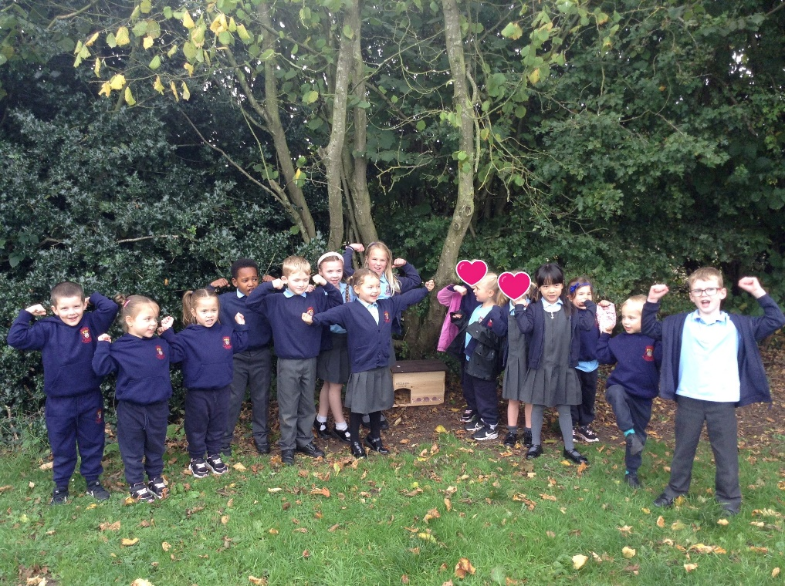KS1 Eco Club: Caring for Wildlife

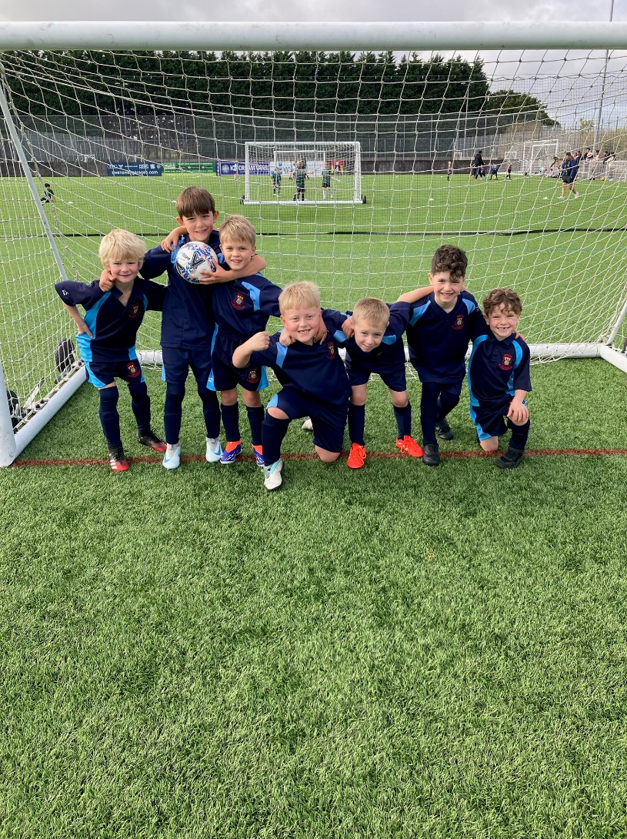Our KS1 Eco Club has been working hard to support local wildlife as we head into the winter months. The children have been busy creating a cozy habitat for hedgehogs and crafting creative bird feeders using Cheerios. These feeders are now placed around the school grounds, including right outside the classrooms, so the children can observe the birds enjoying their new treats. A huge well done to our eco-friendly children for their efforts in making a difference to the environment!

A Successful Football Afternoon

Our Year 1 and 2 football teams had a fantastic afternoon on the pitch, winning several matches, losing only one and scoring an impressive number of goals. The teamwork and determination shown by all the players were commendable. Well done to all the children involved—you made us incredibly proud with your effort and sportsmanship!

Year 3 and 4 Football Superstars

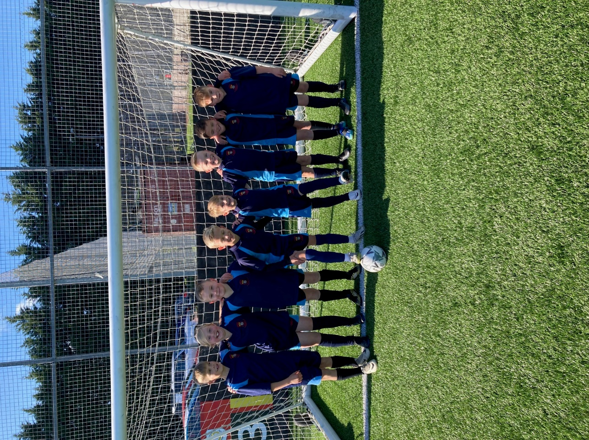Our Year 3 and 4 football team had an incredible afternoon representing Weston in a recent competition. The team played with tremendous energy, displaying excellent teamwork, determination, and impressive skill on the pitch.

Out of all the matches, they only lost one and drew one, securing victories in the rest. The players scored a fantastic number of goals while only conceding two throughout the entire tournament—an outstanding achievement!

A huge congratulations to all the players for their hard work and commitment. You made Weston proud, and we can’t wait to see your team spirit and skills shine in future challenges!

Year 5 and 6 Tag Rugby Team Shines in Competition

Our Year 5 and 6 tag rugby team recently represented the school in a local competition and delivered an outstanding performance. The team won nearly every match they played, showcasing not only their skill and determination but also their exceptional teamwork.

What made us even prouder was the impeccable sporting behaviour they demonstrated throughout the event. Their positive attitude, respect for opponents, and commitment to fair play were a credit to our school.Well done to all the players for their hard work, sportsmanship, and for making Weston Primary proud!

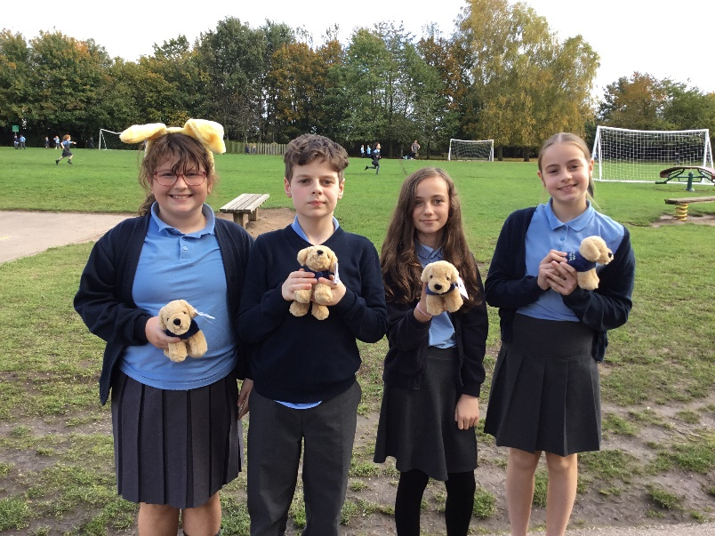Guide Dog Teddy Naming Competition

Our Year 6 Inclusion Ambassadors are excited to announce the launch of a Guide Dog Teddy Naming Competition starting next Monday. For a suggested donation of £2, participants can enter to win one of four adorable guide dog teddies. Donations can be made via Parent Pay, and children will have the opportunity to choose a name during the first break starting on Monday. All proceeds from the competition will go toward supporting the Guide Dogs charity. Let’s show our support for this fantastic cause and join in the fun!

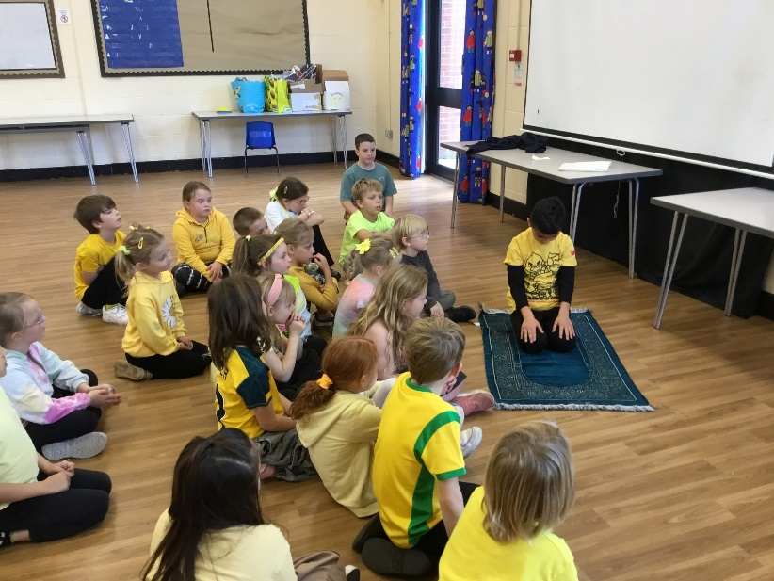Learning About Islam with Aslan

A special thank you to Aslan from Kingfishers class for sharing his knowledge about Islam with his classmates and with children in Blackbirds class. He brought in a beautiful prayer mat and provided an insightful explanation of the prayer process. Aslan also shared an incredible model of a mosque that he created, complete with a mini prayer mat inside. The class learned a great deal from his presentation, and we are proud of the way Aslan confidently shared his faith, helping to promote understanding and celebrate diversity within our school community.

Scholastic Book Fair: A Huge Success!

We are delighted to share that our recent Scholastic Book Fair was a tremendous success, raising nearly £2,000! A special thank you goes to the Knott family, who donated £100 worth of books directly to the school.

Thanks to your amazing support, we have earned nearly £1,000 in commission, which will be reinvested into new books for our school, benefiting all of our children. Your contributions help us foster a love of reading and provide the children with a rich variety of reading materials.

Thank you again for your continued support of our school and our mission to promote reading for pleasure!

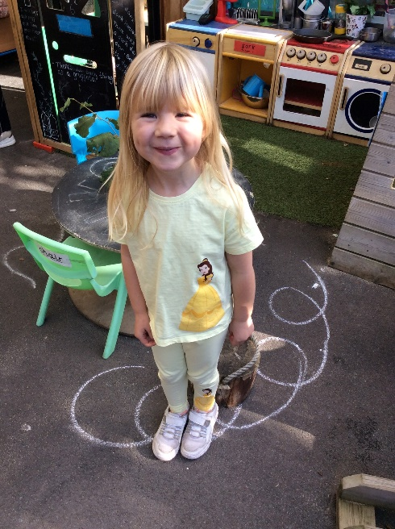Celebrating World Mental Health Day with #HelloYellow

Last week, we marked World Mental Health Day by embracing the #HelloYellow theme, highlighting the importance of mental health and well-being across our school. While we prioritise children’s mental health every day, this event allowed us to shine an even brighter light on the topic.

The children took part in a variety of activities designed to promote well-being, including physical exercise, mindfulness practices and discussions about their emotions. These activities helped reinforce the importance of mental health in a fun and supportive environment.

Our wonderful staff were not forgotten either! The staffroom was transformed with affirmations, treats and a special sausage sandwich breakfast to show our appreciation for all they do.

Let’s continue to talk openly and support each other—not just on mental health day, but throughout the year. Together, we can help create a mentally healthy and caring school community.

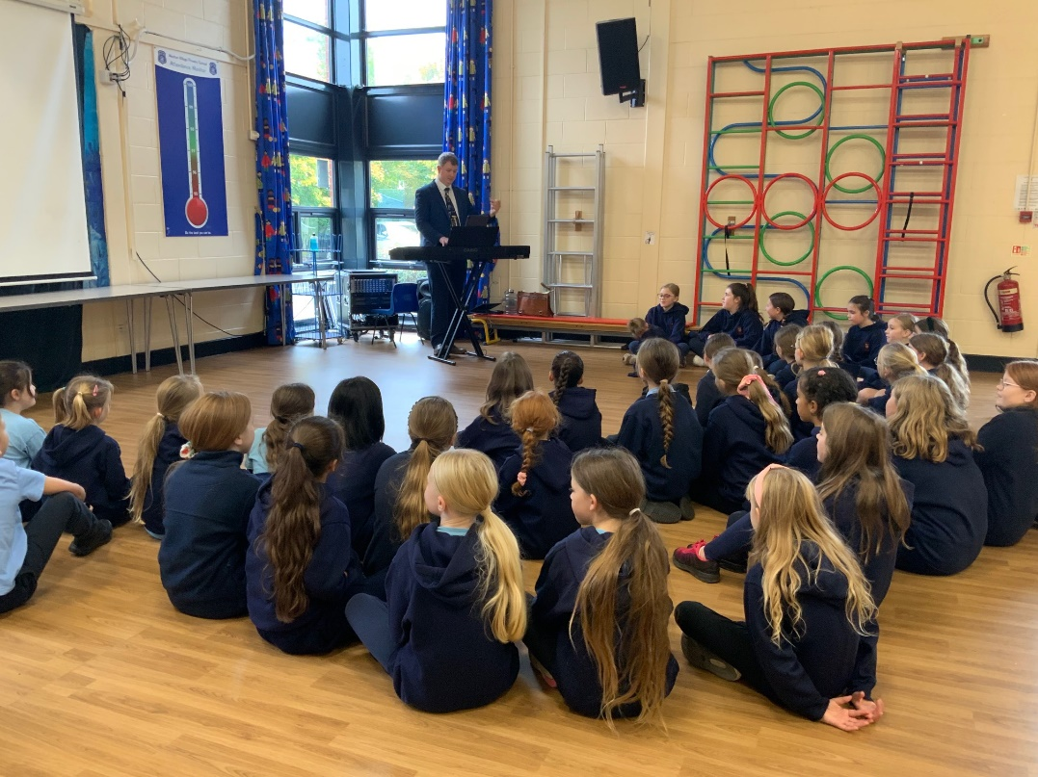Choir Prepares for Christmas Concert

We were thrilled to welcome Mr. Ellum, the Head of Music from Shavington Academy, into school this week. He worked alongside Miss Griffiths and our school choir in preparation for the upcoming Christmas concert at the high school.

The choir will be performing a beautiful rendition of *Somewhere In My Memory* from *Home Alone*, joining forces with Shavington Academy’s performers for this special event. Over the coming weeks, Mr. Ellum will be visiting us again to continue rehearsals with the choir, ensuring they are ready for the big performance.

We’re excited to see our talented children shine and look forward to sharing this festive moment with our community!

Eagles Class Assembly – Next Thursday

We are excited to invite parents of children in Eagles class to their Class Assembly on Thursday, 24th October. Doors will open at 9:50am, with the assembly beginning promptly at 10:00am.

The Eagles are looking forward to sharing a special showcase of their recent learning. It promises to be a wonderful opportunity to see what they’ve been working on and celebrate their achievements.

We hope to see you there to support the children and enjoy the assembly!

Krispy Kreme Doughnut Sale – Next Thursday!

The Friends of Weston are delighted to announce that their popular Krispy Kreme Doughnut Sale will be taking place next Thursday, 24th October. Pre-orders can be placed online and doughnuts will be available for collection on the day.

This is a fantastic opportunity to treat the children while supporting our school at the same time. All funds raised from the sale will go towards enhancing school resources and enriching our children's learning experiences.

Make sure to get your pre-orders in early and thank you for your continued support!

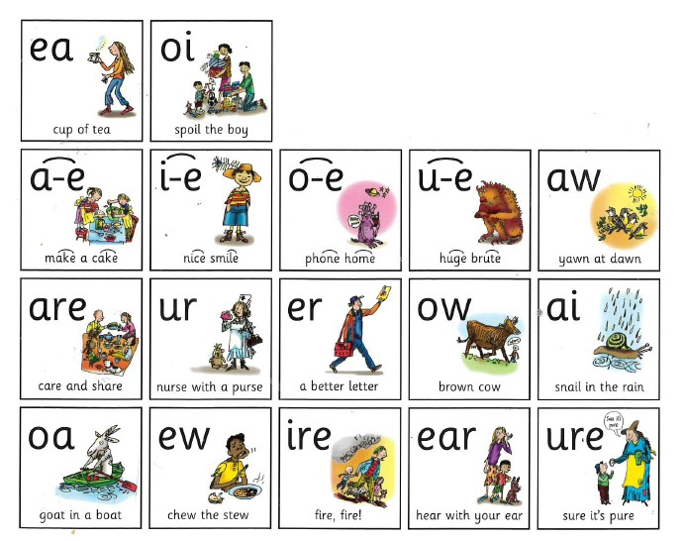Year 1 and Year 2 Phonics Stay and Learn Sessions

We are excited to announce that our Year 1 and Year 2 classes, Robins and Puffins, will be holding Phonics Stay and Learn sessions next week. These sessions provide a wonderful opportunity for parents to observe phonics activities in action and gain insight into how you can support your child’s learning at home.

* **Puffins (Year 2)**: Thursday, 24th October from 8:45am to 9:30am.
* **Robins (Year 1)**: Tuesday, 22nd October from 8:45am to 9:30am.

During these sessions, you’ll have the chance to see first-hand how phonics is taught in the classroom and access useful resources to take home. We look forward to welcoming you and sharing some fun learning activities with you and your child.

Celebrating Staff Achievements

We’re pleased to share that several members of our leadership team have recently completed or are working towards nationally recognised qualifications that will further strengthen our school’s provision and leadership.

Miss Watkins, our Early Years Leader, has recently achieved the National Professional Qualification for Early Years Leadership (NPQEYL). This qualification focuses on best practices in early childhood education and leadership, enhancing Miss Watkins' ability to lead our Early Years and support our youngest learners.

Mrs Loveland is currently working towards the NPQ for Special Educational Needs Coordinators (NPQSENCO), which deepens expertise in supporting children with special educational needs, ensuring all pupils at Weston continue to receive the very best individualised support they need.

Additionally, Mr. Robinson is progressing well with the National Professional Qualification for Leading Teaching (NPQLT), aimed at strengthening leadership in teaching across the school and I have completed the National Professional Qualification for Executive Leadership (NPQEL) and am awaiting the results of my final assessment.

These qualifications are significant and reflect our team’s commitment to continually improving the learning experience at Weston, ensuring that our staff are well-equipped to support all children in reaching their full potential.

Attendance

Here is the most recent attendance. Please continue to support your child's good attendance by getting them into school on time every day and speaking to us if you have any concerns or require support. We will do the same.

|  |  |  |
| --- | --- | --- |
| **Class** | **W/b 7.10.24** | **W/b 14.10.24** |
| Sparrows | 94.7% | 93.3% |
| Robins | 97.8% | 96.1% |
| Puffins | 94.3% | 93.0% |
| Kingfishers | 100% | 98.1% |
| Blackbirds | 100% | 94.1% |
| Magpies | 95.7% | 97.9% |
| Owls | 94.7% | 92.0% |
| Eagles | 97.8% | 98.1% |
| Whole School | 96.8% | 95.3% |

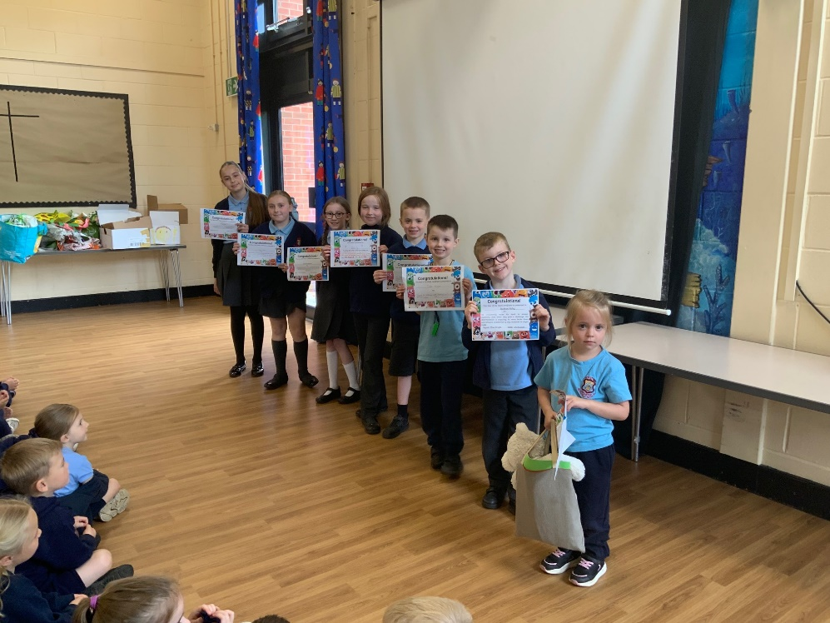Stars of the Week

Here are most of the most recent stars of the week. They embraced the Secrets of Success in a number of different ways and their teachers told the whole school how they had been successful, in Celebration Assembly.

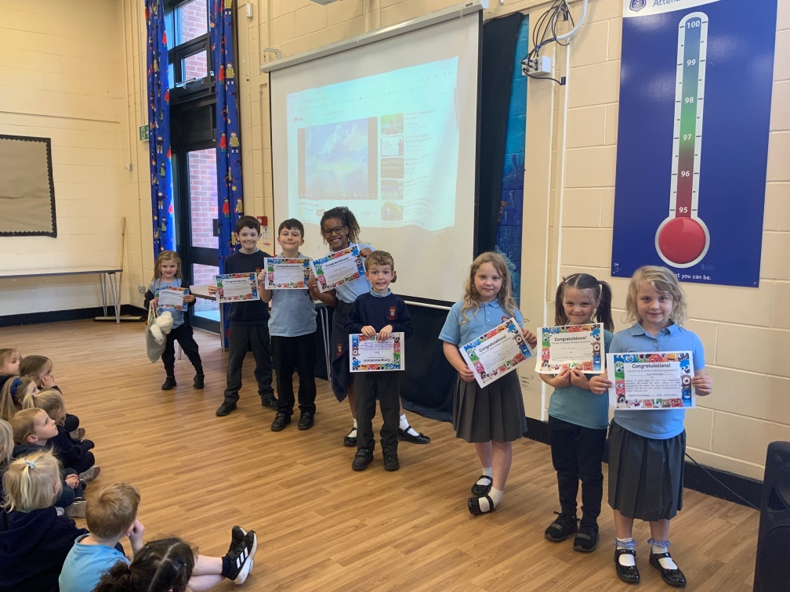

Have You Missed Anything?

Here are the most recent school communications:

* The Hive Autumn Holiday Club
* Scholastic Book Fair
* Drop-off and the Wychwood Bus
* Bikeability Level 1 – Year 4
* Bikeability Level 2 – Year 5
* Parent Governor Election – Ballot Information
* NHS Nasal Flu Vaccinne – Catch-Up Clinics

Thank you for your continued support and cooperation. If you have any questions or need further information, please do not hesitate to contact us.

Thomas Cutts